
Portfolio Optimization and Risk Allocation ASSIGNMNET 1

By

Aphelele Nombila

INTRODUCTION
Understanding asset returns and their distributions is an imperative aspect of financial analysis. This project aims to analyze the historical data of two assets namely, SASOL and ABSA. Both SASOL and ABSA have different market characteristics and return behaviour, which makes them good candidates for studying portfolio optimization and risk allocation.
The data used is daily data ranging from 1 January 2020 to 7 March 2025. Closing prices are used for this analysis and distribution fitting.

- STYLIZED FACTS OF EACH ASSET RETURN SERIES

- SASOL
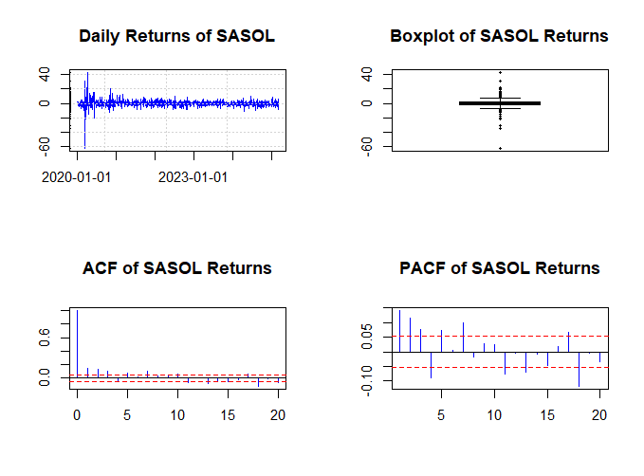
Figure 1.1: Stylized Facts for SASOL
From Figure 1.1 above daily returns, boxplot, Autocorrelation Function (ACF) and Partial Autocorrelation Function (PACF) graphs are depicted respectively. From observing the SASOL’s daily returns, we can see that volatility clustering exists, and we can also see that they are not independent and identically distributed (iid). The boxplot implies that the distribution of SASOL returns is leptokurtic, which is depicted by the long whiskers and outliers. The skewness of this series is -1.525474, SASOL returns are left skewed and therefore large negative returns are more likely than positives. The kurtosis is 41.24746, meaning that extreme price fluctuations for SASOL are very common. The ACF and PACF have some significant sparks which means that the returns of SASOL are not iid and daily returns have low autocorrelation.

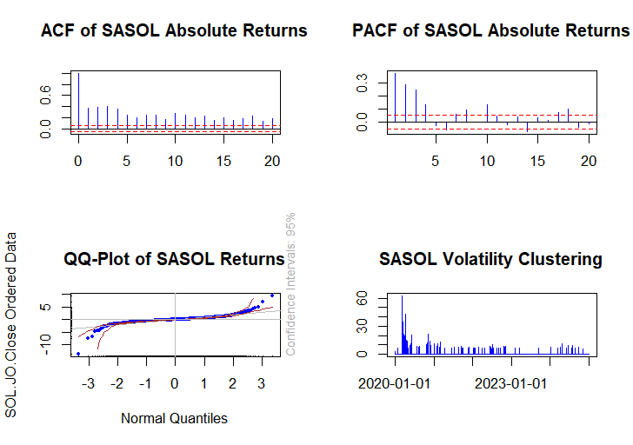
Figure 1.2: Stylized Fact 2 for SASOL
Figure 1.2 also tell us if whether the financial market returns stylized facts hold for SASOL. The absolute return ACF and PACF are plotted at the top. They are significantly different from zero and they reduce slowly. The bottom left graph is the quantile-quantile (QQ) which is compared with the normal distribution. The quantitative values in this graph mirror the negative skew as well as the fat tails. The bottom right graph indicates the volatility clustering, and it also shows that the returns were more volatile in the first half of the of the sample, which can be credited to the Corona Virus Disease of 2019 (COVID-19).

- ABSA
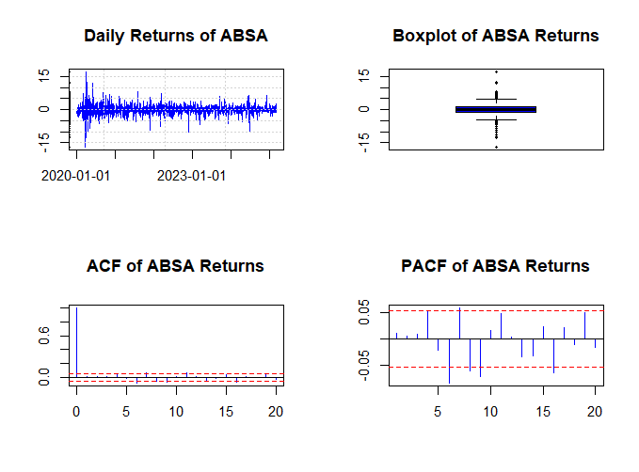
Figure 1.3: Stylized Facts for ABSA
Similarly, ABSA’s return series shows the same characteristics as that of SASOL. Figure 1.3 shows that the daily returns of ABSA are not iid, their distribution is also leptokurtic, the skewness is -0.3519994 which implies large negative returns are more likely to occur than positive, the kurtosis 8.150241 therefore extreme price fluctuations are common, and the ACF and PACF has significant spikes which means daily returns have low correlation.
The stylized facts as summarized in literature by Andersen (1998) McNeil et al (2015), are confirmed in these results.

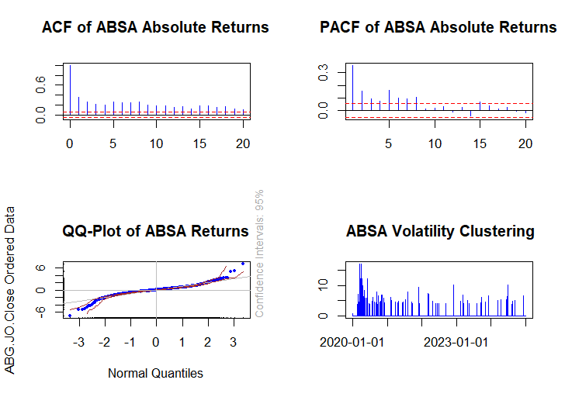
Figure 1.4: Stylized Fact 2 of ABSA
Figure 1.4 likewise confirms the same things as Figure 1.3. It can be seen that both the ACF and PACF of ABSA’s absolute returns have values different from and thus indicating there is volatility clustering. The QQ plot’s quantitative values show that this graph mirrors the negative skew and the heavy tails. The volatility clustering plot shows that ABSA’s returns are volatile but were mostly volatile during the COVID-19 pandemic.

- THE THREE CLASSICAL THEORIES OF PORTFOLIO ALLOCATION

- The Markowitz Model
Before the groundbreaking work of Markowitz (1959), only a few people acknowledged the importance of managing investment and investors focussed on opportunities offered by each equity and not a return-risk relationship.
The mean-variance framework is an investment framework for selecting and constructing investment portfolio based on maximizing expected portfolio returns while minimizing the risk of investment. The model assumes that portfolios are efficient if they are risk minimal for a given return level. Markowitz also assumed that investors only base their decisions on expected returns and risk.
The advantages of this model include the fact that it provides a diversification systematic framework, it helps investors identify the most efficient portfolio, it ensures minimum variance given expected returns, and it is the foundation for modern portfolio theory.
Although the Markowitz model is highly regarded, it also has some disadvantages. One of its disadvantages is that it assumes returns are normally distributed, which is not the case, e.g. SASOL and ABSA’S returns are not normally distributed. The other disadvantage is that it requires precise mean, variance and covariance estimates which are not easy to get.

- The Black-Litterman Model
Black and Litterman (1992) developed a model which aimed to improve the Markowitz model by including the views of investors on asset returns. The Black-Litterman model uses a Bayesian framework to combine historical data together with investors beliefs.
This model assumes that the market portfolio is mean-variance efficient. Another assumption is that the market equilibrium is derived from the implied Capital Asset Pricing Model (CAPM) returns. It also assumes the investors are allowed to express their subjective views on returns of assets.
Its advantages are inclusive of the fact that it is much better for real life applications, as it is used by investors of larges businesses. It betters the Markowitz model by including the views of investors. It also minimizes the sensitivity to estimation errors in mean/variances.
Like the Markowitz model, Black-Litterman model also has its disadvantages. It too assumes that returns are normally distributed, it is more sophisticated than the Markowitz model, and it also requires market equilibrium returns which are not always realistic.

- The Capital Asset Pricing Model (CAPM)
The CAPM is one of the most recognised financial models that describes the relationship between systematic risk and the expected return of an asset. One of its pioneer’s, Sharpe (1977), implied that CAPM suggests that expected return on an asset over the interest rate in equilibrium equals the constant multiplied by its risk.
It assumes that every investor has the same expectation about risk and asset returns. Another assumption is that systematic risk is more important than total risk. It also assumes that markets are perfect.
Its advantages include the that it gives a theoretical connection between risk and return, it gives reason as to why diversification matters, and it can be used for cost of capital estimation.
One of the disadvantages that standout is the unrealistic assumption that every investor has the same expectation. Another unrealistic assumption it has is that there is a risk-free borrowing rate. Also, it does not consider the views and behavioural factors of investors.

- THE STYLIZED FACTS OF THE MULTIVARIATE RETURN SERIES
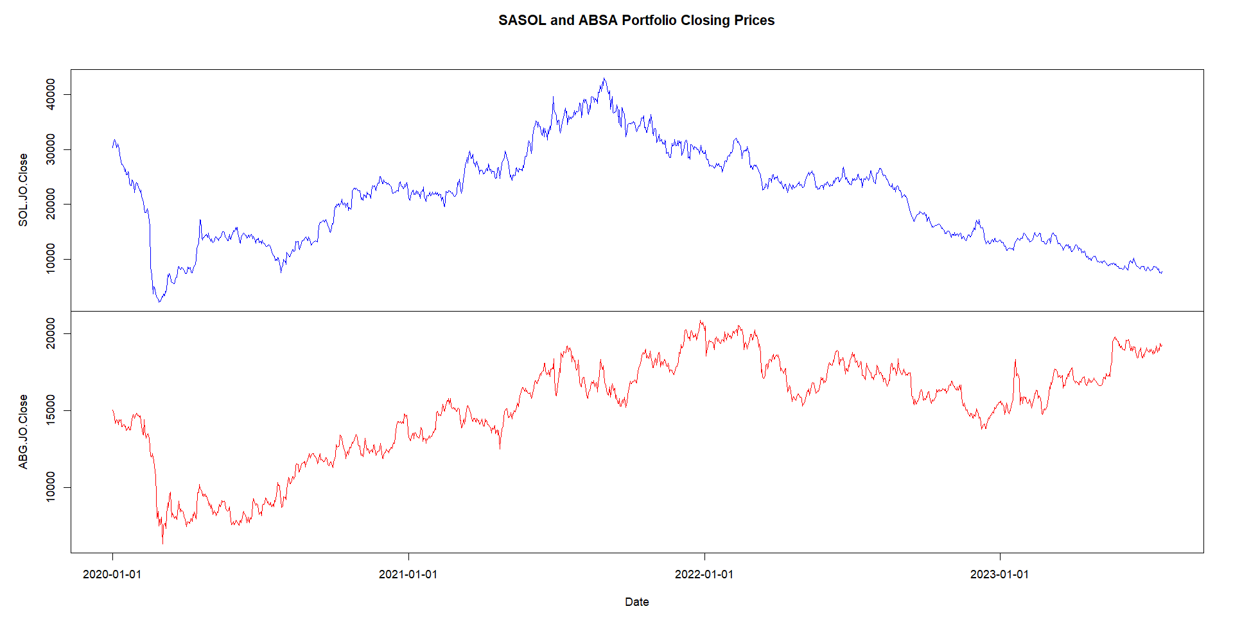
Figure 3.1: SASOL and ABSA Stock Market data

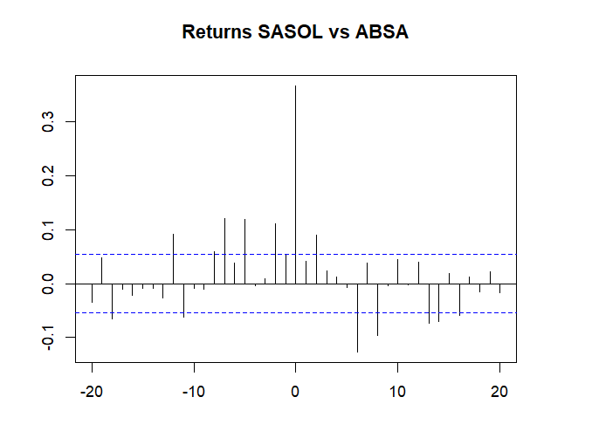

Figure 3.2: Cross Correlation
From Figure 3.2, the most prominent characteristic is the large, positive peak at lag 0. This indicates that there is a strong, statistically significant positive correlation between SASOL returns and ABSA returns at the same point in time. This means that if SASOL's returns are high (or low), then ABSA's returns are also expected to be high (or low) at the same point in time. This significant spike be explained from Figure 3.1, where closing prices were very low during mid 2020 because of COVID-19 but gradually went up at the end of the year.

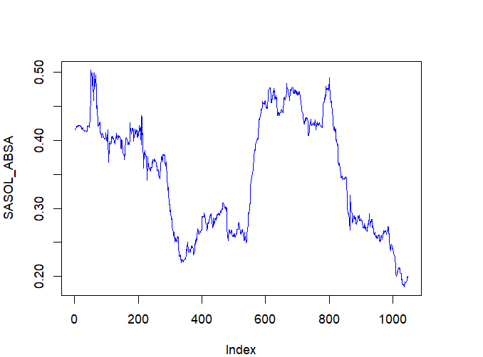
Figure 3.3: Rolling Correlation
In Figure 3.3, the rolling correlation illustrates that SASOL's and ABSA's correlation is not constant and changes with time. Though there is an overall moderately positive correlation, periods of increased and reduced correlation do exist.

- FITTING DISTRIBUTION MODELS

- SASOL

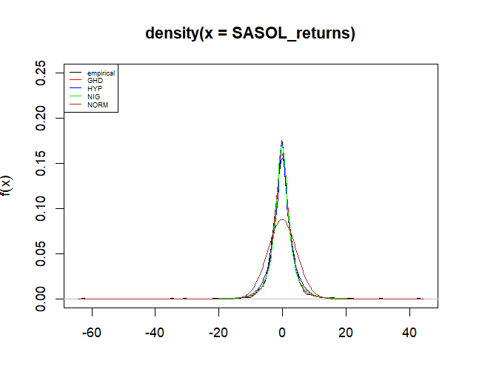
Figure 4.1: SASOL Returns Fitted Densities
Looking at Figure 4.1, the Generalized Hypergeometric Distribution (GHD) and the Hypergeometric distribution (HYP) almost have the exact same densities. The normal distribution fails to capture the excessive kurtosis. The Normal-Inverse Gaussian (NIG) distribution can be said that it explains SASOL returns better than the HYP distribution.
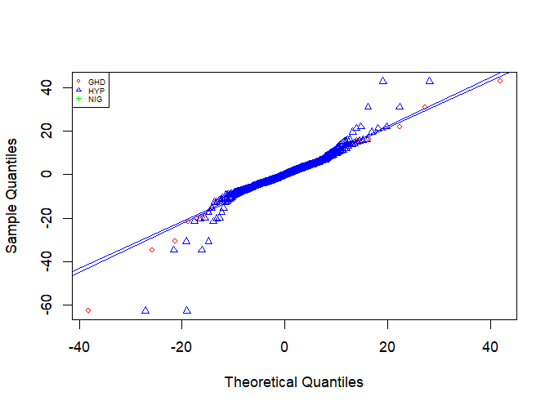
Figure 4.2: SASOL Returns QQ-Plot
From Figure 4.2, we can observe that SASOL’s daily returns can be tracked better with the GHD than the HYP and the NIG distributions.
Out of the 4 distributions visual inspection tells us that GHD distribution is better suited for SASOL returns.
MODEL | AIC | LLH
GHD | 6859.066 | -3424.533
NIG | 6879.637 | -3435.818
HYP | 6944.850 | -3468.425
Table 4.1: Model Fit Table
Table 4.1 above further proves our visual inspection correct, since GHD has the lowest AIC, it is the best fit for SASOL returns.
- ABSA
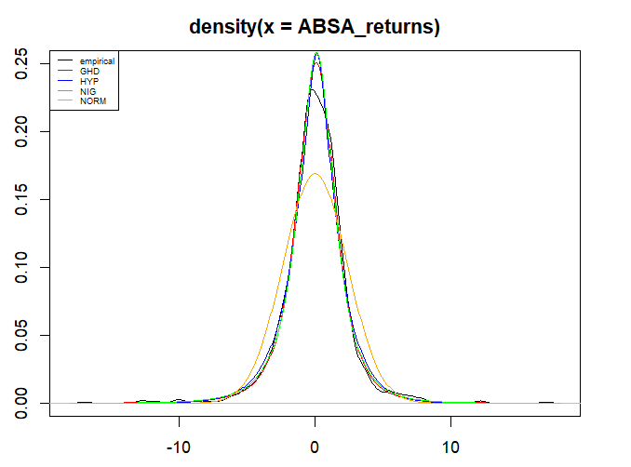
Figure 4.3: ABSA Returns Fitted Densities
The distribution of ABSA’s returns is almost identical to SASOL’s. From Figure 3.4, NIG can be said that is explains ABSA’S returns distribution better than the other three distributions.
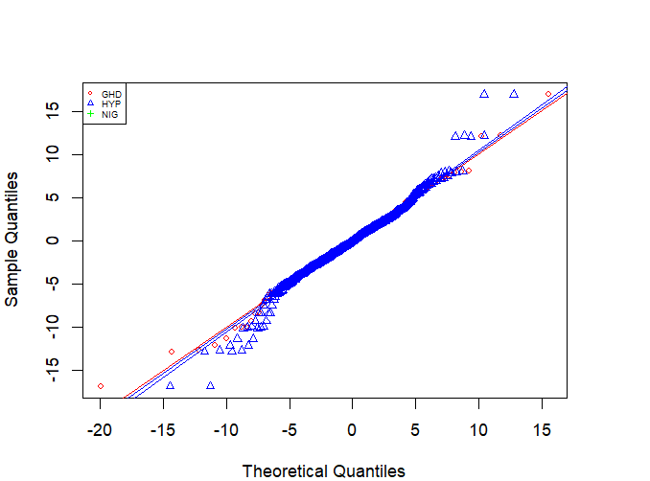
Figure 4.4: ABSA Returns QQ-Plots
From Figure 4.4, it can also be further determined that ABSA’s returns are better distributed using the GHD.

Model | AIC | LLH
GHD | 5574.624 | -2782.312
NIG | 5580.396 | -2786.198
HYP | 5606.617 | -2799.308
Table 4.2: Model Fit Table
Table 4.1 shows that GHD has the smallest AIC and therefore it is the best distribution for ABSA’s returns.

- Value-at-Risk (VaR) and The Expected Shortfall (ES)

- SASOL
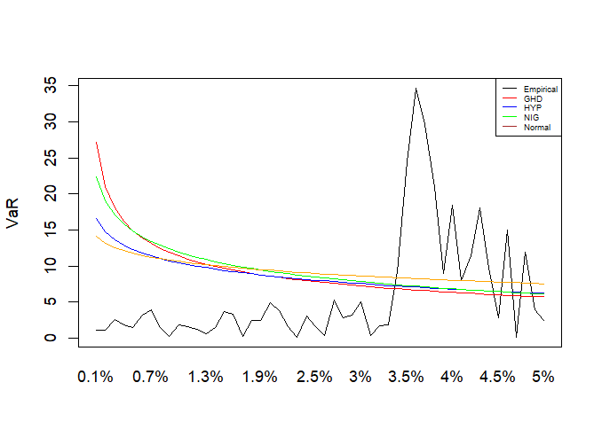
Figure 5.1: SASOL’s VaR Progression
Figure 5.1 suggest that that relying on a normal distribution for VaR calculations would significantly underestimate the risk. The other methods (GHD, HYP, NIG) provide more conservative and realistic estimates. Also, the normal distribution undervalues the VaR.
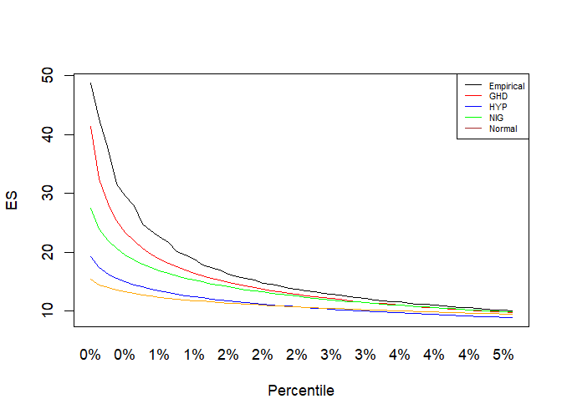
Figure 5.2: SASOL’s ES Trajectory
The Expected Shortfall (ES) plot shows that the normal distribution tends to underestimate risk, with the GHD producing the most negative estimates and hence risking overestimation of risk, especially at lower percentiles where tail risk is most prominent; HYP and NIG produce mid-range ES values, reflecting the central importance of distribution choice in estimating risk, especially when compared to the empirical ES obtained directly from history, which is the standard by which models should be compared.

- ABSA
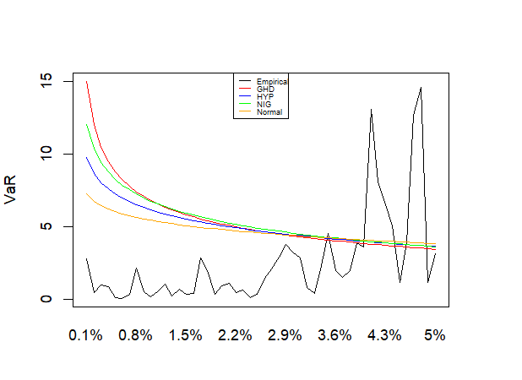
Figure 5.3: ABSA’s VaR Progression
The Normal distribution heavily underestimates VaR. The HYP and NIG distributions provide better estimates, but even these underestimates risk at extremely high confidence levels. The GHD distribution exhibits anomalous behaviour and is not a good choice.
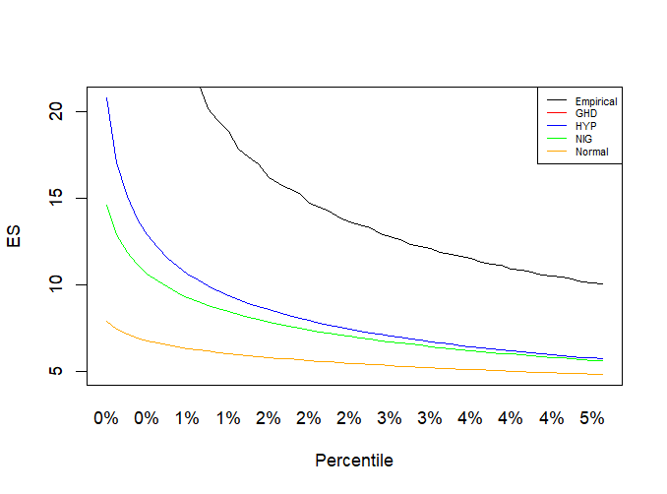
Figure 5.4: ABSA’s ES Trajectory

As in the VaR analysis, the Normal distribution underestimates ES. HYP and NIG distributions provide closer estimates but underestimate at very high percentiles. GHD distribution overestimates ES by a great deal at all percentiles.

- FITTING THE EXTREME VALUE DISTRIBUTIONS, GEV AND GPD

- SASOL
- GEV
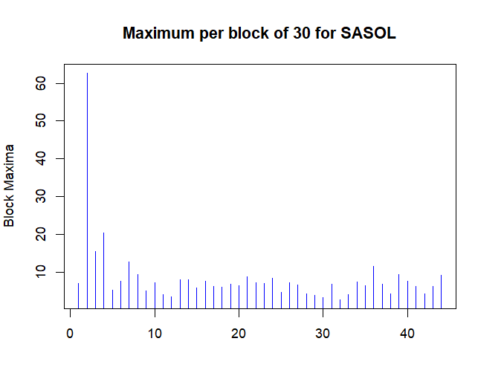 Figure 6.1: Block Maxima for SASOL Losses

The Block Maxima plot on Figure 6.1 indicates that during the first period of the sample period there was high volatility which again was attributed to the COVID-19 pandemic.
The estimated parameters are: $μ$=5.62744, $σ$=2.262246 and $ξ$=0.31. Their standard errors are 0.3790766, 0.3168782 and 0.1108704, respectively.
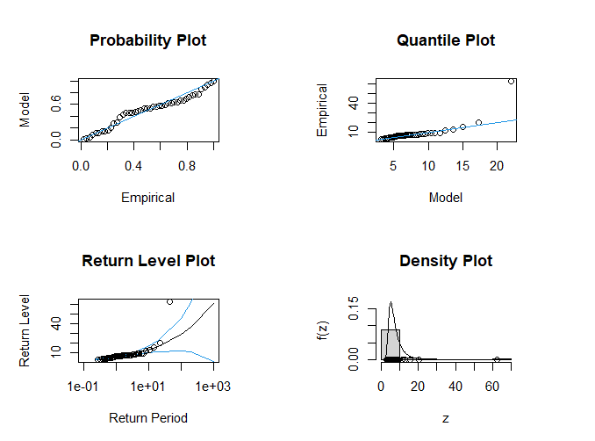
Figure 6.2: SASOL’s Diagnostic plots for fitted GEV model.

From Figure 6.2 we can conclude that although there are some deviations there and there (as indicated by the Quantile plot and Return Level Plot), these plots suggest a reasonably good fit of the model to the data, supporting its use for extreme value analysis and risk estimation.
The calculated VaR and ES for the GEV at 95% confidence level are 2.21 and 2.96 respectively.

- GPD
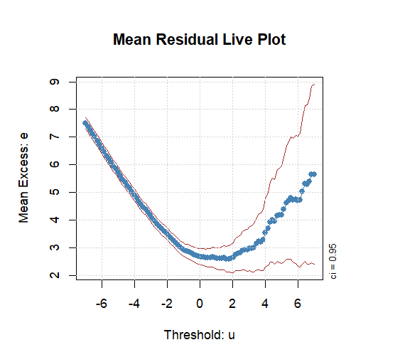
Figure 6.3: SASOL’s Mean Residual Live Plot
Figure 6.3 is a Mean Residual Live Plot (MRLP). This plot reveals that the GPD is a suitable model for SASOL’s losses, specifically the left tail (extreme losses), as evidenced by the linear downward trend. However, it's not appropriate for modelling the right tail (extreme gains).

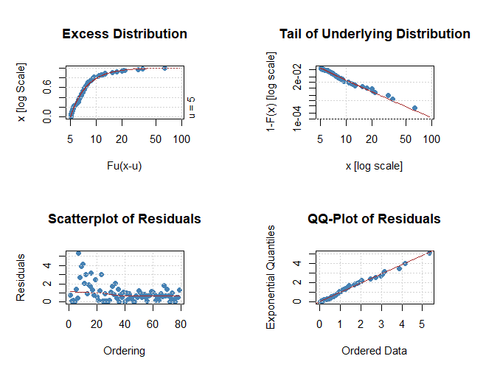
Figure 6.4: SASOL’s Diagnostic plots for fitted GPD Model
These four plots clearly demonstrate that the GPD is a suitable model for the exceedances above the threshold u=5. The tail behaviour of the underlying distribution justifies the use of the GPD, and the residual analysis confirms the correctness of the model. These plots are important for the verification of the GPD model and its reliability for extreme value analysis and risk assessment.

- ABSA

- GEV
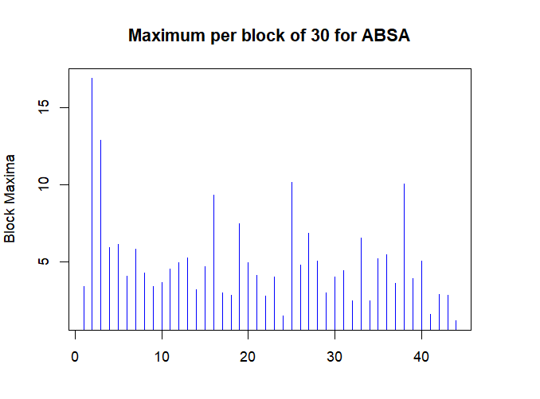
Figure 6.5: Block Maxima for ABSA Losses
Just like SASOL, the volatility of ABSA is extremely high at the beginning of the of the sample period, due to COVID-19. Even after, it can be said that volatility is high for ABSA compared to SASOL.
The estimated parameters are: $μ$=3.6619596, $σ$=1.7656937 and $ξ$=0.1545071. Their standard errors are 0.2967815, 0.2272457 and 0.1074561, respectively.
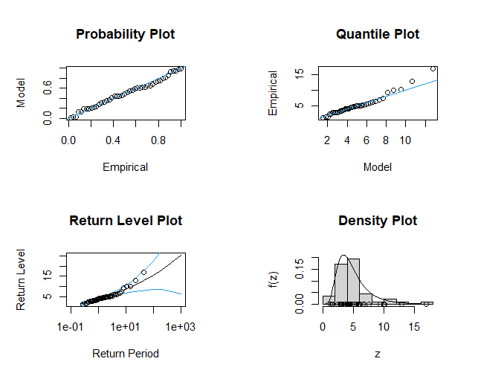
Figure 6.6: ABSA’s Diagnostic Plots for Fitted GEV Model
From Figure 6.6 the plots suggest a reasonably good fit of the model to the data, supporting its use for extreme value analysis and risk estimation.
- GPD
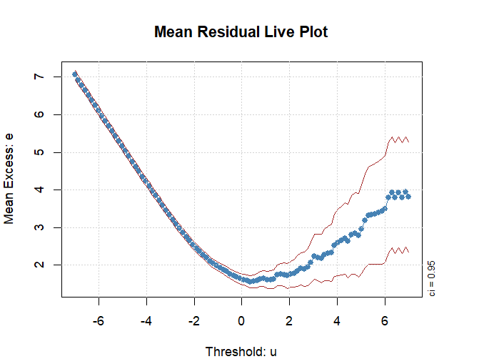
Figure 6.7: Mean Residual Live Plot of ABSA’s Losses
This MRLP for ABSA’s losses reveals that the GPD is a suitable model for the left tail (extreme losses), as evidenced by the linear downward trend. However, it's not appropriate for modelling the right tail (extreme gains).

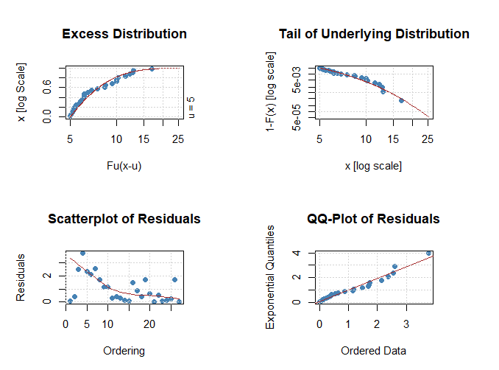
Figure 6.8: ABSA’S Diagnostic plots for fitted GPD Model
Figure 6.8’s four plots clearly demonstrate that the GPD is a suitable model for the exceedances above the threshold. The tail behaviour of the underlying distribution justifies the use of the GPD, and the residual analysis confirms the correctness of the model. These plots are important for the verification of the GPD model and its reliability for extreme value analysis and risk assessment

- FITTING A GARCH-TYPE MODEL

- SASOL

 | Estimate | Standard Error | T value | Pr(>|t|)
$$μ$$ | -0.12684 | 0.077476 | -1.67372 | 0.101589
$$ϕ_{1}$$ | 0.85632 | 0.103061 | 8.3088 | 0
$$θ_{1}$$ | 0.68039 | 0.269569 | -8.9537 | 0.011604
$$ω$$ | 0.08731 | 0.041021 | 2.5240 | 0.001471
$$α_{1}$$ | 0.99604 | 0.037610 | 3.1803 | 0
$$β_{1}$$ | 0.86087 | 0.041021 | 20.9863 | 0
$$γ$$ | 0.99604 | 0.037610 | 26.4833 | 0
$$ν$$ | 4.37872 | 0.560192 | 7.8165 | 0
Table 7.1: SASOL sGARCH(1,1) Parameters

- ABSA

 | Estimate | Standard Error | T value | Pr(>|t|)
$$μ$$ | 0.044200 | 0.038074 | 1.1609 | 0.245689
$$ϕ_{1}$$ | 0.912779 | 0.035472 | 25.7321 | 0
$$θ_{1}$$ | -0.936299 | 0.031842 | -29.4046 | 0
$$ω$$ | 0.158513 | 0.090597 | 1.7496 | 0.080179
$$α_{1}$$ | 0.081509 | 0.029898 | 2.7263 | 0.006405
$$β_{1}$$ | 0.887647 | 0.044212 | 0.20773 | 0
$$γ$$ | 0.931520 | 0.037340 | 24.9469 | 0
$$ν$$ | 4.686661 | 0.617239 | 7.5930 | 0
Table 7.2: ABSA sGARCH(1,1) Parameters
The sGARCH(1,1) model was appropriate for the ABSA and SASOL portfolio because it can capture volatility clustering and time-varying conditional variance, which are common features in SASOL and ABSA return series. It is also a simple but stable model with good volatility estimates that are essential for further risk modelling, e.g., copula fitting.
- ELLIPTICAL AND ARCHIMEDEAN COPULA

- Copula Parameter Estimates
Type of Copula | Parameter | Value
Normal Copula | $$ρ$$ | 0.3729214
Student-t Copula | $$ρ, ν$$ | 0.3759941, 4.035259
Clayton Copula | $$θ$$ | 0.65062945
Gumbel Copula | $$θ$$ | 1.314828
Table 8.1: Copula Parameter Estimates

- Tau Dependence Coefficients
Type of Copula | Tau ($τ$)
Normal Copula | 0.2432878
Student-t Copula | 0.2453974
Clayton Copula | 0.2453669
Gumbel Copula | 0.239442
Table 8.2: Tau Dependence Coefficients

- Tail Dependence Coefficients
Type of Copula | $λ_{L}$ (Lower Tail) | $λ_{U}$(Upper Tail)
Normal Copula | 0 | 0
Student-t Copula | 0.18 | 0.18
Clayton Copula | 0.30 | 0
Gumbel Copula | 0 | 0.22
Table 8.3: Tail Dependence Coefficient

From table 8.3 we can observe that the normal copula has no lower or upper tail dependence since it is symmetric but light-tailed and its limited ability to capture joint extreme events. In contrast, the student-t copula captures symmetric dependence in the lower and upper tails due to its heavy tails, as it has non-zero lower and upper tail dependence parameters. The clayton copula exhibits strong lower tail dependence, signifying greater joint extreme losses, and is therefore best suited to downside risk modelling. By contrast, the gumbel copula exhibits upper tail dependence, signifying its ability to model joint extreme gains or co-movements upwards in the data.

REFERENCES
Black, F. and Litterman, R., 1992. Global portfolio optimization. Financial Analysts Journal, 48(5), pp.28-43.

Markowitz, H., 1959. Portfolio Selection: Efficient Diversification of Investments. New York: John Wiley & Sons.
Sharpe, W.F., 1977. Asset allocation tools. The Journal of Portfolio Management, 3(1), pp.7-13.

